Human Aspects of Computer Science (HACS)  
Open Group Assessment: Experimental Study

GROUP E6

Maya Jovanovic

Oliver Driver

Matthew Gilmore

Jamie Todd

Yuqing Gong

Shixin Ji

Heng Xu

**Introduction** **3**

**Method** **5**

Aims and Hypotheses 5

Design 5

Participants 6

Materials 6

Procedure 6

**Results** **7**

**Discussion** **8**

**Ethical Procedures** **9**

**Appendix** **10**

**References** **14**

## Introduction

When users play video games, a certain level of immersion usually comes over the player. Immersion is the deep mental involvement in an activity, causing the user to exert a great level of concentration and more often than not, become unaware of events happening in their surroundings. Users can find a loss of peripheral vision and lose track of time as they are focusing on a task. Here, we would like to test the limits of immersion in users when they are performing a task.

There are many factors that can cause different levels of immersion for users when playing video games. One factor is the size of the screen that is being used to play the game. If a user is playing on a smaller screen, it is found that the user is less immersed in the game. Likewise, if the screen is too large and the user is too close, immersion will be lower. These hypotheses were proved in *Effects of screen size, viewing angle, and players’ immersion tendencies on game experience* [1]. In our experiment we plan to use only one screen size, which will be monitored as all researchers will conduct the experiment in the same room with the exact same equipment. Additionally, participants will sit the same distance from the screen to give better repeatability between researchers. Resultantly, screen size will have no effect on the user.

The paper *Measuring and defining the experience of immersion in games* [2] suggested that one of the important factors that can affect the level of immersion is emotional involvement: gamers who did not feel total immersion talked of lack of empathy and the transfer of consciousness. In our experiment, we plan to ask our participants to do a questionnaire which consists of questions relevant to a person’s motivation, for example: “To what extent did you feel motivated while playing?”, “How much did you want to “win” the game?”, and “Did you feel that you were trying you best?”. We think the result will show that a participant who is more willing to “win” the game will be far more immersed in the game.

In the paper *Video Games: Perspective, Point-of-view, and Immersion* [3], the author explains the differences, pros, and cons of first vs third person playing, as well as how each POV can impact immersion within a game. They also cover how spatial understanding and optical perspective of the game is a large factor of immersion within the game. They concluded that while first person gaming enables a head on view of what is happening through the players eyes, third person gaming allows the user to actually experience the gaming environment in a more perceptive way; giving them perspective on size and dimensions within the gaming interface. There wasn’t an actual method used in this paper, however; the paper was more of an analysis of gaming in general as opposed to a research paper with gathering data. We aim to see if this is the case, by gathering our participants data.

The paper we found named “*First Person vs. Third Person Perspective in Digital Games: Do Player Preferences Affect Immersion?*” [4] aimed to see if a first person perspective is more immersive than a third person one in video games. The aim was examined by having gamers play an RPG game in their preferred perspective and evaluate immersion subjectively. The reason the researchers had for doing the experiment was that immersion of video games is becoming more important to both video game producers and players these days, and while modern games give players more options, like letting them choose from first person perspective and third person perspective, the researcher seeks to investigate which is more immersive and if a player’s personal preferences on perspective affects their immersion on each of them. In the paper, researchers used a method that they led their participants played early quests from the main questline of the game “The Elder Scrolls V: Skyrim” in a environment that was a simulated living room. After 15 minutes of playing, participants were interrupted by the researchers and filled out a demographics questionnaire. In our experiment, we used a similar method to investigate the effect of immersion that we asked each participant to play the game “Minecraft” and after 15 minutes of play, we interrupt them and give them a questionnaire to fill out.

The paper *“A Grounded Investigation of Game Immersion”* [5] by Emily Brown and Paul Cairns describes work done to develop a grounded theory of immersion and interviews with gamers about the immersion state while they play same game. The constructed grounded theory which is a robust division of immersion, it divides immersion into the three levels: engagement, engrossment and total immersion. The researchers aimed to specify the term ‘immersion’ means in gaming and how does gamers understand and describe the term and they showed gamers share same concept about the term ’immersion’ but it is also not a static experiment that it is described a scale of involvement with a game. In our experiment, we added some question about the immersion the participants experienced in the questionnaire and considered as a variable in our final data statistics.

The report *“Game immersion experience: its hierarchical structure and impact on game‐based science learning”* [6] is to investigate ‘How does immersion affect students’ science learning through Serious educational games(SEG) play’ and the relationship between immersion and science learning outcomes remain few. SEG is a kind of video games which are used to help teaching and learning. In the experiment, we found that some of our participants remember the name of items and some of the mechanism in their second try in a different perspective.

The paper *“In The Game : An Exploration of the Concept of Immersion in Video-Games and its Usage in Game Design.”* [7] showed what are the factors leads to immersion within a video game and what it actually is. The researchers found that immersion is a result of a series of gameplay factors: challenge/competition, control, feedback, goals; and world setting factors: aesthetics, curiosity, satisfaction, fantasy, interest and narrative.

We chose a game that has a some of the factors but the experiment was not aimed at whether these factors are important for players to develop a immersive experience.

## Method

### Aims and Hypotheses

We hypothesise:

*When playing Minecraft, a greater level of immersion is achieved when the user is playing first person compared to when the user is playing third person.*

The aims of this experiment are to create a level of reproducibility between each participant and have a controlled environment where there aren’t any distractions that could distract a user in one experiment and not in another. We aim to do this by hosting the experiment in a privately booked room where we can control outside distractions.

### Design

In designing the experiment, we took into account distraction factors and that we didn’t want our participants to know how long they are playing for, to better understand the depth of immersion within a game. Our design plan was as follows:

1. Have a quiet room separate from any outside distractions. We thought it best to do this so that the participants are as immersed as possible.
2. Not have them be aware of the time or how long they are playing for. To implement this, we would make it clear to the participants that they will not be allowed to look at their phones or any watches, and we would also hide any clock in the room used.
3. Leading on from this, they would have a time limit that we would not disclose. However, they are free to stop playing if they feel they have either completed the task at hand, or just feel like not playing anymore.
4. They were to start from a completely random start point within the game for each perspective. This way, they can't just resume what they were doing already. This is particularly important for those participants who have never played the game before, as diving into the new perspective would be a new challenge without a kind of basis for resuming.
5. They have a vague task to follow. It doesn’t have to be a strict task due to the nature of the game (creative worldbuilding). In this case, the task was to build a house. However, the participants were given free reign to explore the world if they so wished (if it caught their interest). Essentially, the task would be implemented as a way to see how interested they are with it and subsequently, the game as a whole.
6. The independent variables are the time the participant plays for, the distance from the screen, and the point-of-view perspectives. We “measure” the participant’s levels of immersion within the game with a given questionnaire at the end. Essentially, the dependent variable is how long the participant thinks they’re playing for.

### 

### Participants

A within participant design is a design in which all participants of an experiment test all conditions of a given hypothesis. In our case, all participants will play both a first person perspective and a third person perspective. The reason we used a within participant design is because it is more effective for a smaller group of participants and would give us more statistically correct results.

Most of our participants weren’t part of our cohort within the course, with several of them never having played Minecraft before. However, this is beneficial as the experiment will give a results for a wider set of participants as it isn’t mainly focused on Computer Science students, who may have more practise than other people. Resultantly, this will give us a more statistically accurate representation of the population as a whole, as opposed to a specific cohort with likely previous experience and familiarity with the game. This could mean a decrease in levels of immersion so we wanted to keep it neutral and unbiased.

Overall, we had a total of 25 participants who took part in our experiment.

### Materials

For the experiments, the participants each had access to the Xbox controller, a control map (shown in the appendix as figure 1) and a consent form. Once the participant had finished with the experiment, they were given a questionnaire to complete. This questionnaire was completed twice by each user, outlining their results for both first and third person perspectives. The immersion questionnaire we used was one we were provided with before the experiment, however it was slightly altered in order to record the times in which the participant thought they were playing each perspective for and how long they were actually playing for.

Additionally, the researchers will have access to a tape-measure in order to measure the distance between the chair the participant will sit on and the TV. This is so that screen size doesn’t affect immersion.

### Procedure

Before the experiment began, each member of our group booked a room and a time slot in which they could complete the experiment. All group members booked out the same room in order for each participant to have the same experience. At the time of the experiment, each group member collected the Xbox and set up the room in which the experiment was being held. This included; removing the clock from the wall, connecting the Xbox to the TV and setting up the game, and closing the blinds to prevent outside distractions. Additionally, the researcher measured a distance of 2.5m between the chair and the TV.

Once everything was set up, participants were invited into the room one-by-one and asked to remove any wrist watches and phones. Consent forms were given and then a brief explanation of the game mechanics and controls was given. Participants were then allowed to start playing the game, and help was given if asked for. The researcher started a timer which only they could see. After this unknown amount of time to the participant, the game was switched to the third person view and the participant continued playing from scratch.

When the participant finished, they were asked the amount of time they thought they had been playing on each perspective for. This was recorded alongside the actual time they were playing for by the researcher once the questionnaires had been completed. We ended up giving them an average time of 15 minutes per perspective. The questionnaire was to be completed twice by the participant, the first time showing results for their first person perspective gameplay and the second time showing results for their third person perspective gameplay. The questionnaires were collected and the participant was thanked and left the room, allowing another participant to undertake the experiment after the questionnaires were hidden from the previous participant.

## Results

In total we gathered 25 sets of data (one for each participant) with each participant playing the video game Minecraft in both first and third person. Each person filled out the questionnaire which was used to gather various types of data to gain a hold of statistics of the player’s immersion for the respective POV’s. Additionally, at the end of each questionnaire, we asked the participant on their perceived playtime for the POV’s and noted them down alongside the results, since a good representative of game immersion is loss of track of time [9].

From the collected results, we calculated mean values from the questionnaire, along with a summation of the positive representatives for player immersion, the negative representatives and average times. These results show a small but distinct favour towards playing Minecraft in first person to be more immersive and the statistics represent why.

On average, participants felt that first person perspective was 11% more attention grabbing, 20% less aware of the controls, and 6% more focused in first person and generally felt they performed better in first person. Now although these results may seem as conclusive facts, they are the players opinions on what the experience was like for them and we cannot conclusively justify confirming our hypothesis based solely on these alone, although they help towards it.

However, we asked participants for their perceived times as well, which can prove these opinionated results, and found that players believed the length of time they played the game in first person was 5.5% less than the actual value, but also thought they played in third person perspective 8.5% longer than they actually did. Not only did they lose track of time, however, it was differently in each case, with players feeling the playing experience was dragged out in third person which negatively impacted their immersion and experience. To confirm this we conducted a Mann Whitney U test to see if these values are statistically significant. If they prove to be statistically different, then we can reject the null hypothesis that “When playing Minecraft, third person is more immersive than third person”.

A type 1 error is when we incorrectly reject the null hypothesis when instead we should have maintained it. This is usually due to researchers incorrectly thinking they have found a genuine correlation with their hypothesis. We can successfully agree that we do not have a type 1 error by measuring the significance level to be below 0.05 (5%).

A type 2 error is effectively the reverse. This is when we believe there isn’t a genuine correlation when there actually is. We can successfully agree that we do not have a type 2 error when the maximum accepted probability of the error is below 0.2 (20%).

A type 1 error is unlikely to have occurred in this experiment which is why the Mann Whitney U test was carried out, to prove this and why our findings were correct. Our value of 0.013 shows there was a 1.3% chance that the values obtained from our experiment were random which is less than the standard significance level of 5%. However, if the participant sample size were larger, then this chance would be lowered.

Since our experiment is greater than just a few people (25), it is statistically unlikely that we encountered a type 2 error since these mostly appear in experiments with very small participant sizes, although there is still a very minimal chance. To eliminate this chance completely, we could have run the experiment on a larger sample size of participants.

The probability of 0.013 found from the Mann Whitney U test shows that it is statistically insignificant that the values from the timing are incorrect or random which means we can then reject the null hypothesis “When playing Minecraft, third person is more immersive than third person” therefore showing that the point of vision in the video game Minecraft does affect immersion and that the first person perspective is more immersive than third person perspective.

## Discussion

This research find there is relationship with a greater level of immersion is achieved when the user is playing first person compared to when the user is playing third person. In this research, there are only 25 participants, which may be limited. The results cannot represent the actual general average value. Therefore, the result was found in this research may not be significant. In addition, there are lots of factors may affect this study such as the environment factor and different between the participants.

Firstly, the game which was used in our experiment that does not have a strong aim, so some of our participants were confused what they should do during the time. The research from Jennetta shows that the immersion of the game could be affected by whether the game have a final goal [6]. Therefore, the participants may think the experiment is meaningless, so they will be distracted by the surrounding instead of paying attention to the game.

Secondly, some of the participants knew how to play the game while other participants have not played the game or have even heard about it. This makes some of our data become an outlier, so it may be unreliable. The experienced gamers knew how to play the game and had a strong immersion during playing, while the ones who do not know the game thought the game was completely meaningless and makes they did not got any immersive experience during playing as they were wondering when will the experiment will be finished.

In addition, we didn’t specify the range of age of our participants, and the younger ones may focus on different things in game thus the data from them may be outlier results. The research from Emanuel shows that humans of different ages have different ability for focus [8]. In this experiment, we do not have age limits which means the result was found in this research could not be significant. Some younger people are more easily immersed than older ones. However, all of our participants were between the ages of 18 to 24, so we can safely say that we have a solid ground for a similar ability of focus and interest.

As a final disadvantage of our study, the graphic of our game could be considered extremely poor. The whole screen was full of pixels (which is essentially the design of the game, not a resolution flaw), which may have made the first time players feel as if the game is not real, thus leading to it not being easy to develop an immersive condition. Despite this, results from the questionnaire we gave them gives conclusive evidence that overall, the players did not feel negatively about this while playing, and that it didn’t affect immersion levels.

For the advantages of our experiment, we firstly ensured that all the participants played the game on the same Xbox and same controller, so the gaming condition will not be changed so much as it might be considered as an hidden factor in the experiment. Secondly, we let every participant play in both perspectives to see whether the questions they answered support our hypotheses. This made sure that the participants that have played other games and may have had a preference on the perspectives can answer the questionnaire in a more unbiased way. Finally, all the participants were asked to play in the same “world” in the game. This is a good way for controlling variables within the game.

For the improvement of this experiment, we can increase the amount of time the player plays the game for. Since the time is limited in this experiment to 15 minutes, this is quite short for participants to get fully immersed into the game. We did find that we had some outliers where a couple of the players were playing for much longer than the 15 minute limit due to neglection of the strict limits by some of the researchers. In future experiments we agree that we would need to be a lot stricter with the timings. These outliers can be seen in Figures 2 and 3 in the appendix (the Y axis is the amount of time played, while the X axis is the participant number), where the large peaks on the graph are the longer times being played by a certain player.

Additionally, we can create a much more solid aim for participants to achieve, which would enable the participants to know what they need to do in the game, so that they don’t have to play this game without a clue. Finally, we need to properly specify the age group, for example “18 to 20”, and the participant should have some game experience for whichever game they play (in this case, Minecraft).

In conclusion, the result we found prove that the hypothesis is right. We found that a greater level of immersion is achieved when the user is playing first person compared to when the user is playing third person. Although this investigation has some shortcomings, our results are relatively accurate.

## Ethical Procedures

Before each experiment, we gave each participant a consent form to read and sign in order to take part in the experiment. The consent form explains the information about the researchers’ name, the purpose of the study, how the data will be used and shared between our researchers. On the consent forms, we briefly explain the process of the experiment: the name of the game, the environment, how the participants play the game and what do they need to do after the experiment.

We gave our participants the opportunity to ask questions about the experiment before and after the experiment, however, if they had any question about how to play the game, they had to be asked before the experiment began. We also give our participants full rights to participate and stop the experiment at any time if they wish, and for the unused data to be destroyed.

The purpose of the consent form is to provide participants with a plain language statement that describes the aims of the study and the nature of involvement of participants. We asked them to sign their name at the end to make sure that they read and understand the information provided on the consent form, and make sure that they know their rights during the experiment.

However, on the questionnaire we had no trace of the participants name or any information about their personal selves. This kept the anonymity of the participants that were undertaking the experiment. The questionnaires and the consent forms were then separated and questionnaires collected were referred to using, for example, Participant 1.

## Appendix

Appendix 1: Our consent form.

Ethics Participant Consent form

The purpose of this form is to tell you about the study and highlight features of your participation in the study.

**Oliver Driver**

**Jamie Todd**

**Matthew Gilmore**

**Maya Jovanovic**

**Shixin Ji**

**Heng Xu**

**Yuqing Gong**

**Department of Computer Science, York**

**January, 2019**

1. **Who is running this?**

The people running this experiment are all computer science students at the university.

1. **What is the purpose of this study?**

The purpose of this study is to investigate how the viewpoint of a character in a game

affects the immersion of the player.

1. **What will I have to do?**

Play the game *Minecraft* in two situations, where both times your aim is to build a house/building. You can do this in anyway you want. Feel free to explore the game as you wish and get creative. Whilst playing the game, we ask that you do not use your mobile phone and remove any wrist watches.

You will be given a small sheet showing the controls for the game.

After you have finished playing the game, the researcher will ask you a couple of questions related to the experiment and will lead you to complete a questionnaire about how you felt the game went.

1. **Who will see this data?**

This data will be shared between all researchers listed at the top of this document and furthermore be shared with Dr Will Smith and any colleagues in which he may see fit to view the document.

1. **Do I have to do this?**

This experiment is completely voluntary. You may stop the experiment at any time and if you wish, the data can be destroyed.

1. **Can I ask questions?**

Questions are welcome before and after the experiment. If you would like to ask questions about how to play the game, please do this before and the researcher will give you a quick guide on the basics of the game.

1. **Consent**

In order to participate in the experiment, please write your name and sign below where necessary. By doing so, you agree to participate in the experiment and it will indicate that you have read the information written above.

**Participant name :**

**Participant Signature:**

**Researcher name:**

**Researcher Signature:**

**Date:**

Figure 1.

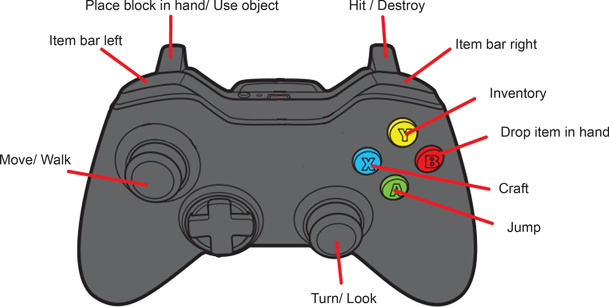

Figure 2.

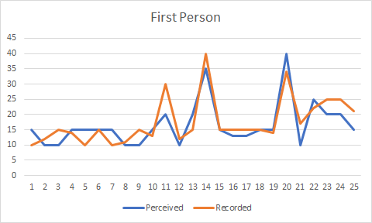

Figure 3.

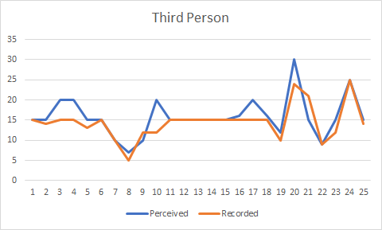

Figure 4.

|  |  |
| --- | --- |
| Discrepancy between perceived time and recorded time (minutes) | First Person(1)/Third Person (2) |
| 5.00 | 1 |
| -2.00 | 1 |
| -5.00 | 1 |
| 1.00 | 1 |
| 5.00 | 1 |
| .00 | 1 |
| 5.00 | 1 |
| -1.00 | 1 |
| -5.00 | 1 |
| 2.00 | 1 |
| -10.00 | 1 |
| -2.00 | 1 |
| 5.00 | 1 |
| -5.00 | 1 |
| .00 | 1 |
| -2.00 | 1 |
| -2.00 | 1 |
| .00 | 1 |
| 1.00 | 1 |
| -6.00 | 1 |
| -7.00 | 1 |
| 3.00 | 1 |
| -5.00 | 1 |
| -5.00 | 1 |
| -6.00 | 1 |
| .00 | 2 |
| 1.00 | 2 |
| 5.00 | 2 |
| 5.00 | 2 |
| 2.00 | 2 |
| .00 | 2 |
| .00 | 2 |
| 2.00 | 2 |
| -2.00 | 2 |
| 8.00 | 2 |
| .00 | 2 |
| .00 | 2 |
| .00 | 2 |
| .00 | 2 |
| .00 | 2 |
| 1.00 | 2 |
| 5.00 | 2 |
| 1.00 | 2 |
| 2.00 | 2 |
| 6.00 | 2 |
| -6.00 | 2 |
| .00 | 2 |
| 3.00 | 2 |
| .00 | 2 |
| 1.00 | 2 |

## References

[1] J. Hou, Y. Nam, W. Peng and K. Lee, "Effects of screen size, viewing angle, and players’ immersion tendencies on game experience", Computers in Human Behavior, vol. 28, no. 2, pp. 617-623, 2011. Available: 10.1016/j.chb.2011.11.007

[2] C. Jennett et al., "Measuring and defining the experience of immersion in games", International Journal of Human-Computer Studies, vol. 66, no. 9, pp. 641-661, 2008. Available: 10.1016/j.ijhcs.2008.04.004

[3] L. N. Taylor, "Video Games: Perspective, Point-of-view, and Immersion", MA, University of Florida, 2002.

[4] A. Denisova and P. Cairns, "First Person vs. Third Person Perspective in Digital Games: Do Player Preferences Affect Immersion?", in 33rd Annual ACM Conference on Human Factors in Computing Systems, 2015, pp. 145-148.

[5] E. Brown and P. Cairns, "A grounded investigation of game immersion", Extended abstracts of the 2004 conference on Human factors and computing systems - CHI '04, 2004. Available: 10.1145/985921.986048.

[6] M. Cheng, H. She and L. Annetta, "Game immersion experience: its hierarchical structure and impact on game-based science learning", Journal of Computer Assisted Learning, vol. 31, no. 3, pp. 232-253, 2014. Available: 10.1111/jcal.12066

[7] C. Odeja, "In The Game : An Exploration of the Concept of Immersion in Video-Games and its Usage in Game Design", Bachelor of Science Honors, Edith Cowan University, 2007.

[8] M. Emanuel, T. Jarus and O. Bart, "Effect of Focus of Attention and Age on Motor Acquisition, Retention, and Transfer: A Randomized Trial", Physical Therapy, vol. 88, no. 2, pp. 251-260, 2007. Available: 10.2522/ptj.20060174

[9] R. Wood, M. Griffiths and A. Parke, "Experiences of Time Loss among Videogame Players: An Empirical Study", CyberPsychology & Behavior, vol. 10, no. 1, pp. 38-44, 2007. Available: 10.1089/cpb.2006.9994